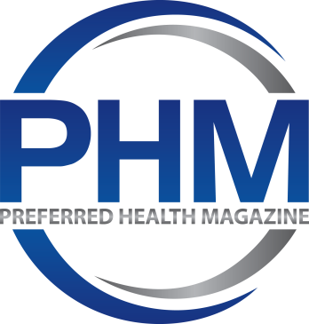 Advertise with us
Preferred Health Magazine is among the leading publishers of health and wellness information nationwide. Advertising with PHM is a highly-effective way to reach consumers, physicians, and healthcare professionals for your product or service.
The cover of PHM hosts celebrity interviews and top physicians who bring a following of new readers to each issue. Inside, PHM content covers health and wellness topics, medical technologies, medical research, lifestyle/ beauty, alternative/holistic medicine, as well as book reviews and profiles of experts in the healthcare industry.
We have the ability to run targeted campaigns for a variety of categories. We also receive organic search traffic from Google, Yahoo, and other search engines on hundreds of health related search queries and keywords. These visitors are more likely to be interested in advertisements for health related products and services.
We offer a wide variety of advertising options and solutions including:
- Print ads
- Social Media ads
- Website Banner Ads
- Promotional Video Ads
- Billboard ads
- Product ad with Interview (Book, Services, Product)
- Podcast Interviews

You can also reach out to us if you have alternate advertising opportunities in mind.
Preferred Health Magazine (PHM) offers brands the targeted opportunity to educate patients and facilitate dialogue with their physician at a crucial time - right before they see their doctor.
Distributed in print and electronically to thousands of physicians’ offices nationwide, PHM includes 4 prime advertising positions, [Inside Covers front and back, First Page, and Back Cover] giving brands the opportunity to “hold rank” in the publication with guaranteed exclusivity.

HOW COVID 19 IS CHANGING THE PLATFORM:
Since 2019, online health-related searches have sky-rocketed. An estimated 7 percent of Google's daily searches are health-related, according to Google Health Vice President David Feinberg, MD. Google's total daily health-related searches amount to 70,000 each minute, according to reports.
Let’s face it, the Coronavirus has changed the way we think about hygeine. That is why PHM’s online presence is taking center stage with more celebrity interviews, hard-hitting topics, and trending health concerns that people want to learn about in order to live a healthier lifestyle. Our cover interviews have included some of today’s most influencial figures including Deepak Chopra, Larry King, Fran Drescher, and Montel Williams. Inside featured articles have included indepth reporting of ‘Mob Mentality’ and ‘The Covid Brain’; and have included profiles of today’s top “Patient Preferred”physicians throughout America.

POINT-OF-CARE ADVERTISING WORKS:
> The average patient spends 20 minutes in the waiting room
> 84% more likely to talk to a doctor about an ad they saw while in the waiting room
> 64% switched brands after seeing or hearing patient messages at the POC
> 69% of caregivers read magazines and/or pamphlets in the doctor’s office

Preferred Health Magazine Advertisements & Pricing
FRONT COVER B  (COVER PAGE/B  with inside feature interview)  BACK COVER  BILLBOARD ADS | PREMIUM PRICES Inquire Within  Interviews must be health related
Inside Front cover- Full page | $2,500. (3x Issues)
Inside Back Cover- Full page | $2,000. (3x Issues)
8 X 10” Full-Page  8.67" W X 11.25" H | Single Issue: $595.00  3x issues: $1350  First 10 pages add $200.
Half Page 8.62 W x 5.61 H | ½ page Single Issue - $400.  1/2 Page (3x issues) - $ 1,000.  First 10 pages- add $200
2/3 PAGE AD  8.67"W X 7.26" H  (with Bleed)  ​ | 2/3 page Single Issue - $500.  1/2 Page (3x issues) - $ 1,200.  First 10 pages- add $200
1/3 Page 8.62W x 3.75H | 1/3 page Single Issue- $350.  1/3 page (4x issues) - $ 900.  First 10 pages add $200.
¼ Page 4.20” W x 5.51” H | ¼ page Single Issue $250.  ¼ page per year (4x issues) $600.  First 10 pages add $200.
Website Banner Ad Display  Home Page | $250. per month (30 Day Display)  $2,000 per year- paid up-front (12 month display).

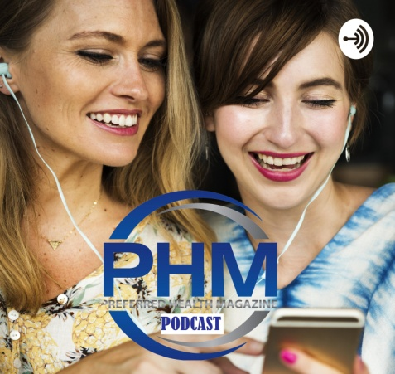
“TALKING POINTS” PODCAST With PREFERRED HEALTH MAGAZINE
30-45 MINUTE INTERVIEW FOR YOUR PRODUCT OR SERVICE
$300.
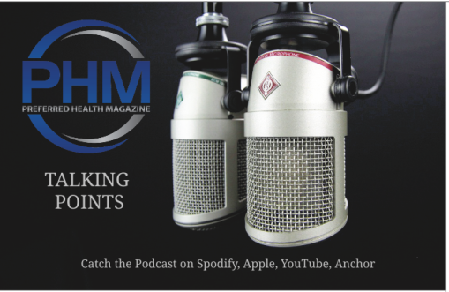
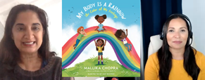

***Billboards, Reviews, Podcast Interviews, Videos = Custom quotes depending on scope of project.
Advertising policy at Preferred Health Magazine
- Advertising must not be misleading or make fraudulent claims.
- Advertising must comply with all applicable laws, regulations and codes.
- Preferred Health Magazine (PHM) reserves the right to reject any advertisement, for any reason whatsoever, at its sole discretion.
- Advertisers must confirm in writing they have the right to use any third party’s intellectual property e.g. trademarks, copyright, graphics, etc.
- We do not accept advertising that contains pictures or text advocating
prejudice or discrimination against any race, national origin, religion, disability or handicap, gender, age, or sexual orientation.
- We do not accept advertisements for betting, lotteries or gambling.
- We do not accept tobacco, tobacco brand or tobacco product advertisements.
- We do not accept firearm/weapons advertisements.
- We do not accept any advocacy ads, political party or candidate advertising.
- We do not accept advertisements directed at children.
- We do not accept advertisements that are designed to collect personally identifiable information from visitors to the PHM Website without their knowledge or permission.

FULL-PAGE ADS
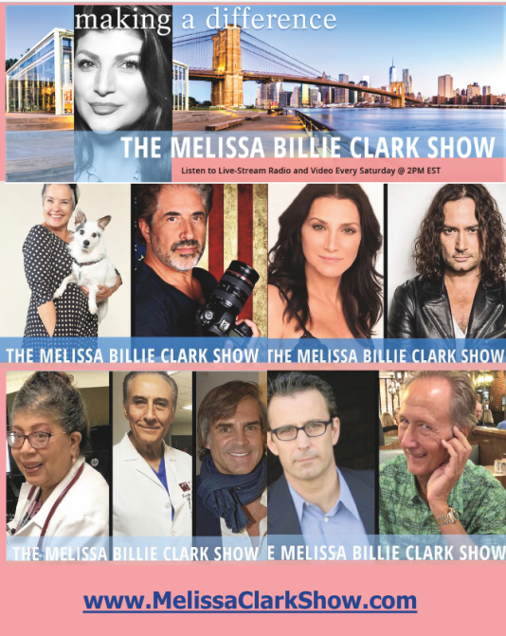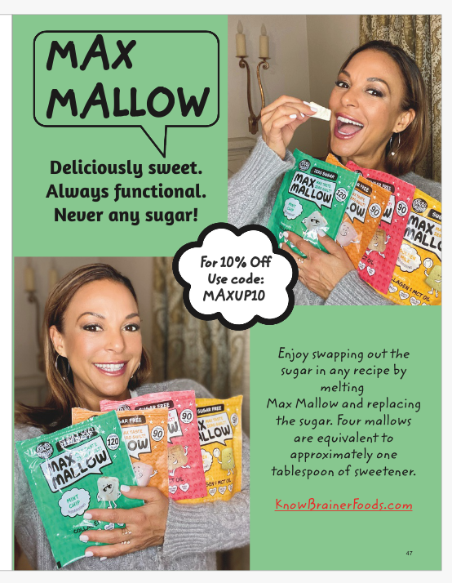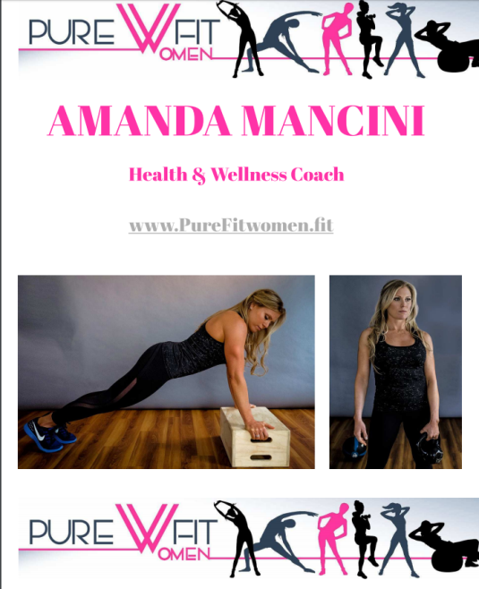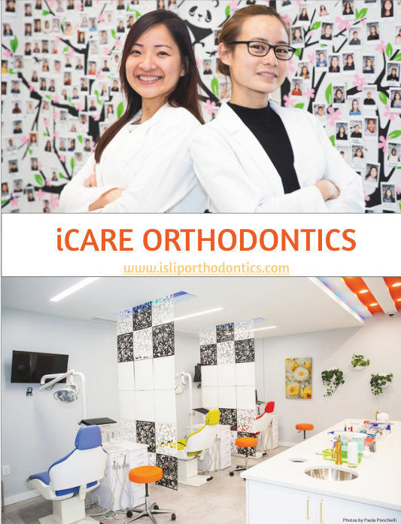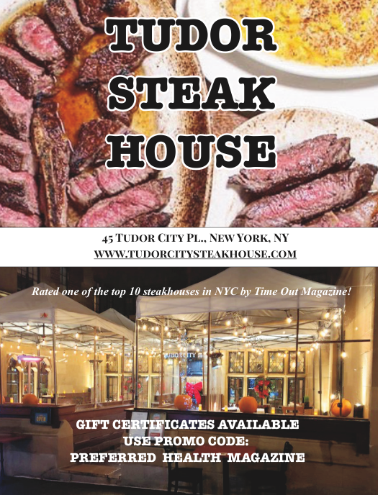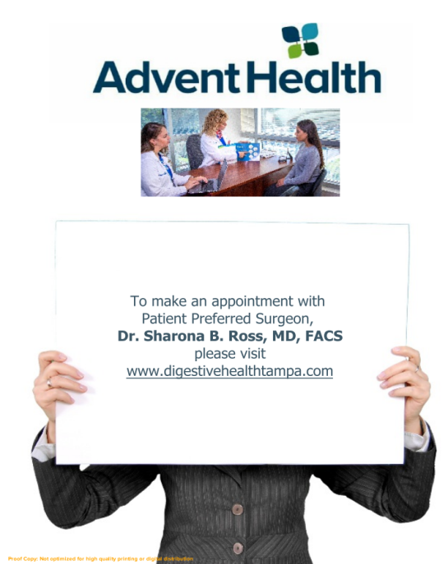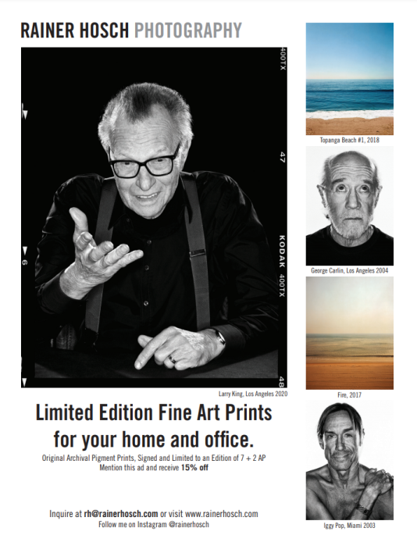

BOOK REVIEWS, PRODUCT INTERVIEWS, & PROFILES
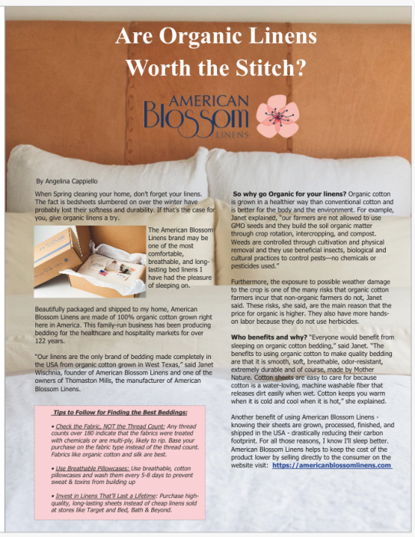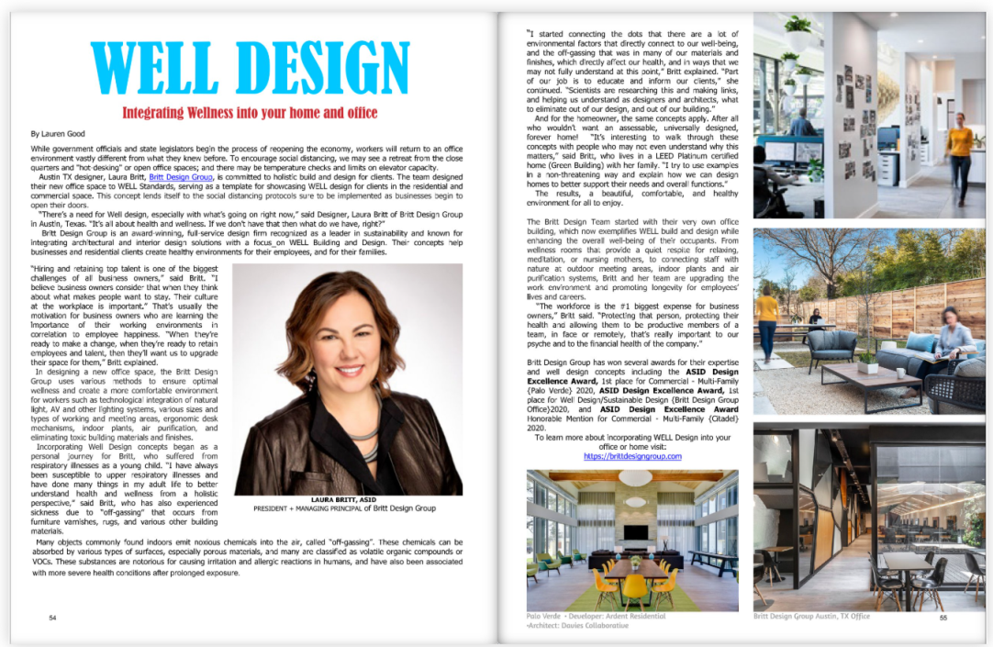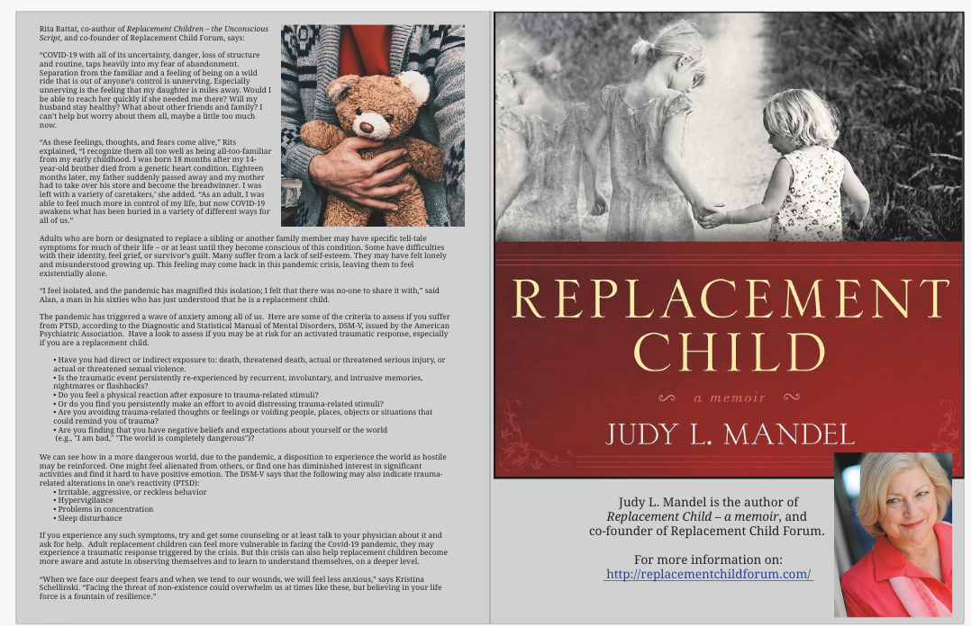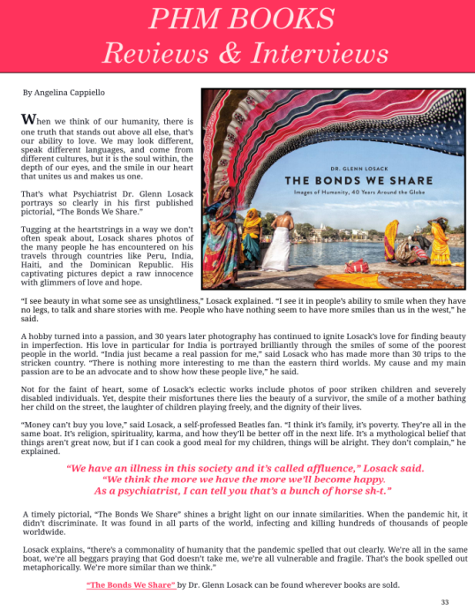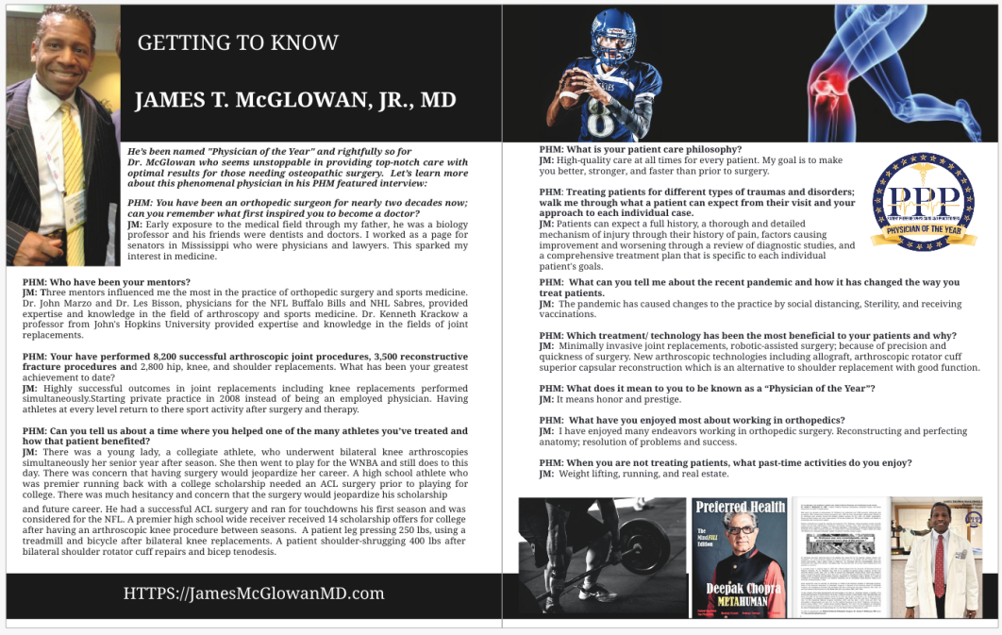

LIVE DIGITAL BILLBOARD DISPLAYS : Prices Vary

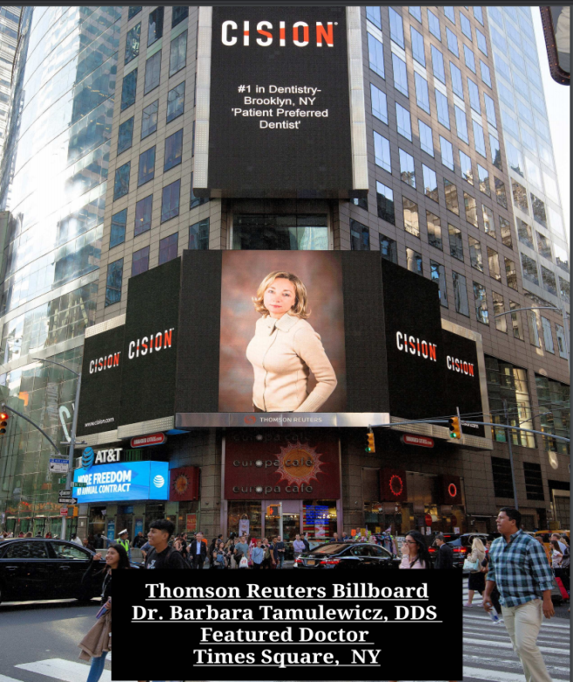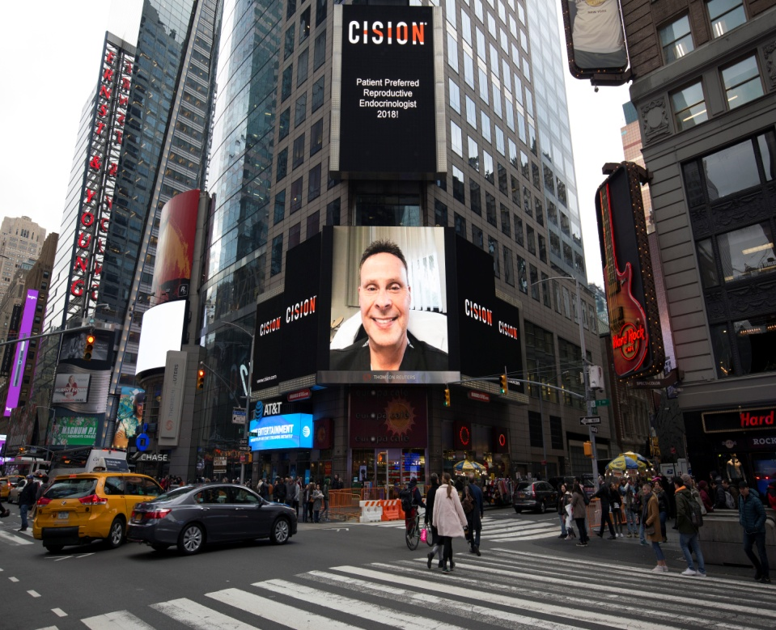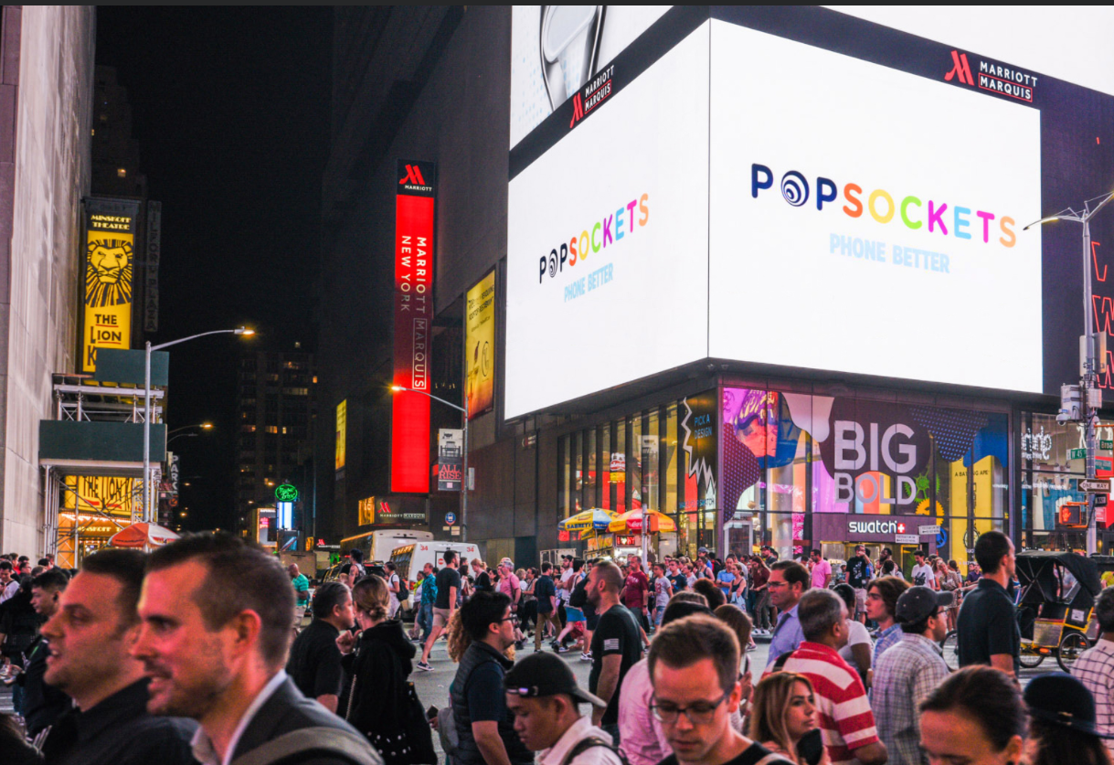

CELEBRITY COVER & INTERVIEWS

